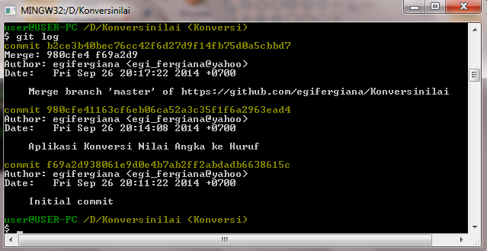

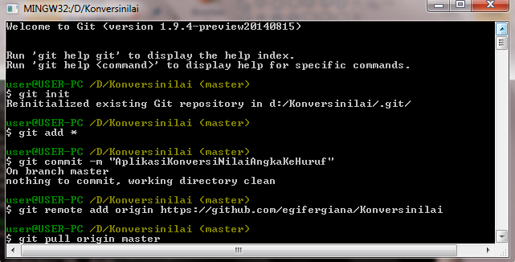

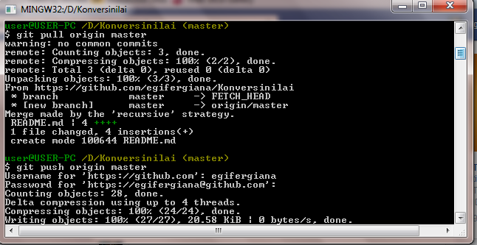



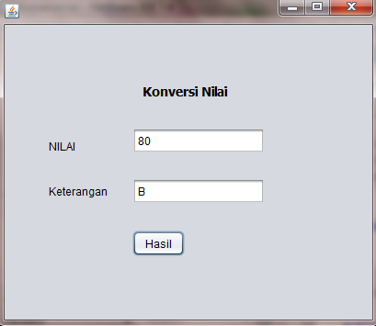

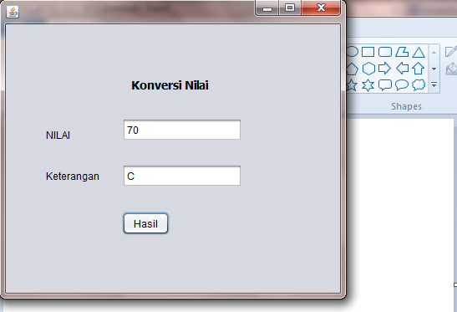

Git Log

$ git log

commit b2ce3b40bec76cc42f6d27d9f14fb75d0a5cbbd7

Merge: 980cfe4 f69a2d9

Author: egifergiana <egi_fergiana@yahoo>

Date: Fri Sep 26 20:17:22 2014 +0700

Merge branch 'master' of https://github.com/egifergiana/Konversinilai

commit 980cfe41163cf6eb06ca52a3c35f1f6a2963ead4

Author: egifergiana <egi_fergiana@yahoo>

Date: Fri Sep 26 20:14:08 2014 +0700

Aplikasi Konversi Nilai Angka ke Huruf

commit f69a2d938061e9d0e4b7ab2ff2abdadb6638615c

Author: egifergiana <egi_fergiana@yahoo>

Date: Fri Sep 26 20:11:22 2014 +0700

Initial commit